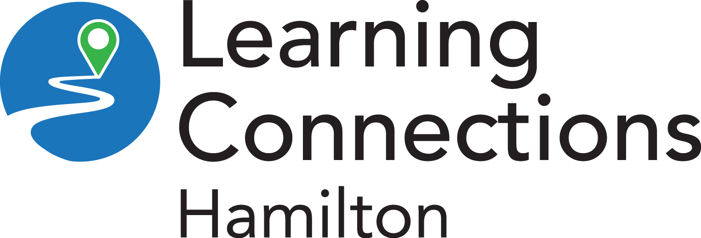
Your Logo Here

Learning Exploration Report – [Client’s Name]

This tool will help you explore how you learn, your learning strengths and possible areas to further develop. We’ll also help you explore learning strategies that might be helpful for you.

Date | May 8, 2026
Learning Support Person
Goals
Employment*
Education and Training
Skills Upgrading | [What are you currently working on in the program?]

*The Job Bank has job profiles and Essential Skills profiles for many jobs. These can be very helpful to determine the skills needed for the job.

Learning Summary
Strengths | [You can add things here from the strengths table or from additional strengths and skills that came out of the rest of the interview.]
Processing Challenge Areas | [If the client has several checks in one of the processing challenge areas, list it/them here (visual, auditory, organizational, attention, etc.]
Specific Markers | [Optional – here you could include very specific things like has difficulty tracking, sensitivity to light, difficulty with decoding using phonics, etc.]
Learning Strategies to Try | [Start a list of specific strategies the learner could try, maybe offer a learning strategy handout if appropriate.]
Strengths
As adults we all have strengths that we bring to learning, work and life. These strengths are diverse and unique to you. They help us learn, grow and interact with others. Recognizing your strengths will help you in your learning.
Talents, Interests and Hobbies | [What do you like doing? What are you good at like cooking, sports, art, crafts, building, mechanics?]
Communication and Interpersonal Skills | [like being a good listener, respecting other people’s ideas, learning from others, helping others, collaborating with others, conflict resolution]
Personal Values and Internal Strengths | [like being kind, determined, dedicated, resilient, resourceful, dependable, responsible, flexible, integrity, independent, creative, problem-solving, adaptable, self-improvement, honest, self-reflective, leader, work ethic, positive attitude, respect]
Favourite Things to Learn | [maybe a subject like math or science or a specific topic]
Skills | [like language, reading, writing, math, computers, typing, working on machinery, using tools, hand-eye coordination, cooking, parenting]
What are you proud of?
Work/Volunteer History (types of jobs, for how long, skills developed)
List of Values - https://www.berkeleywellbeing.com/list-of-values.html

Learning Preferences
Learning Preferences/Needs | [What is your ideal learning environment?]
Classroom Learning | Do you like working ☐ on your own ☐ in a group
Digital Notes | ☐ Has a digital device [ - if yes, include what]  ☐ Has access to Internet [ - if yes, include what]  ☐ Has a smartphone [ - if yes, include plan details]  ☐ Comfortable learning online [ - include notes]
Barriers to Learning that May Need to be Addressed | [Is there anything preventing you from taking your next step? This could be anything like childcare concerns or transportation to being hesitant to entering a learning environment again.]
Learning Strategies | [Do you use any learning strategies, assistive devices, apps, etc. when learning?]

Learning Exploration
Checked boxes are “yes”.
When you were young (grades 1-6)
☐ Did you enjoy school?
☐ Do you feel that you did well in school?
☐ Were you able to learn new material easily?
☐ Did you feel comfortable learning new skills?
☐ Did you miss a lot of school? (moved frequently, were ill for long periods, etc.)
☐ If you missed a lot of school, do you think this has impacted your skills?
In your daily life,
☐ Do you like to read (magazines, novels, social media, etc.)?
☐ Do you like to write (posts, emails, notes, etc.)?
☐ Do you like doing math (budgeting, shopping, measuring, etc.)?
Additional Comments

Health/Medical Information that May Affect Learning
Vision Issues | Y/N  [Do you have any issues with your vision? If so, do you wear corrective lenses? If not, does your vision effect you when you’re learning? If so, how?]
Hearing Issues | Y/N  [Do you have any issues with hearing? If so, do you use hearing aids or other devices? If no, does your hearing affect you when you’re learning? If so, how?]
Ongoing Health Concerns | Y/N  [Do you have other health issues that may affect your learning? If so, how?]
On Medications | Y/N  [Are you on any medications that might affect your learning? If so, how?]
History or Concerns with Substance Use | Y/N  [Have you ever had substance use issues that might affect your learning? If so, how?]
Lives with Anxiety/Depression or Other Mental Health Challenges | Y/N  [Do you live with any mental health challenges that may affect your learning? If so, how?]
Stress Level | ☐ Low (0-3) ☐ Medium (4-6) ☐ High (7-10)  [Ask the learner to rate their stress level on a scale from 0 (most happy) to 10 (most stressful). If they have a very high stress level (8-10), you may want to discuss this and determine if additional supports are needed.]
Previous Diagnosis of Disability | Y/N  [Have you ever been diagnosed with a disability, either visible or invisible? If so, will it affect your learning? If so, how?]
Recommended Actions | [If there are things that may impact their learning, you may want to make recommendations here that could include wrap around supports or things like looking into getting glasses, etc.]

Daily Tasks | Can Do | Some Difficulty or Difficult | Notes
shopping (estimating cost, counting change, etc.) | ☐ | ☐
handling money and/or banking | ☐ | ☐
using public transportation | ☐ | ☐
keeping track of time | ☐ | ☐
housekeeping | ☐ | ☐
using the phone | ☐ | ☐
cooking | ☐ | ☐
remembering things - if so, is it short- or long-term memory? | ☐ | ☐
communicating with others | ☐ | ☐

General Learning
☐ Do you have great difficulties learning new skills in specific areas (like writing)?
☐ If yes, have you always had these difficulties?
☐ Do you feel that you have great strengths or talents in some areas and a great amount of
difficulty in others (for example, a great strength in woodworking, but a great difficulty in
writing and spelling)?
☐ Did you ever repeat or skip a grade?
☐ Did you ever receive extra help in school? For example, resource class, resource teacher,
special education class, individualized education plan (IEP)?
☐ Did you work hard in school but still found you had difficulties understanding the material
or doing well?
☐ Do any members of your family have difficulties with reading, writing, or math or have
been diagnosed with a learning disability?
☐ Have you ever been formally assessed for a learning disability?
☐ If English is not your first language, did you have difficulty learning to read and write in
your first language?
☐ Have you had many jobs for short periods of time?
☐ Did you leave any jobs because of difficulties with reading, writing, and/or math?
☐ Have you ever avoided a job because of the skill requirements like reading, writing or
math?
Comments

Learning Processing
Visual Processing Challenges
Do you have difficulty with any of the following? Checked box is “yes.”
☐ getting headaches after reading or writing for a short time
☐ having really tired or red eyes after reading or writing for a short time
☐ seeing words move on the page, shake or fall off the page
☐ seeing the difference between similar words – like “horse” for “house”
☐ keeping your place when reading (do you skip words or lines often?)
☐ remembering the look of a word (maybe you have to sound it out many times)
☐ spelling words correctly (you spell based on how it sounds)
☐ copying information
☐ working in columns (when answering math questions like long division or adding long
numbers stacked on top of each other)
Comments

☐ Do you consider this a challenge area for you?

Auditory Processing Challenges
Do you have difficulty with any of the following? Check any of the boxes for “yes.”
☐ avoiding reading, especially out loud
☐ reversing letters
☐ putting letters in the wrong order when reading or spelling
☐ adding letters or leave letters out when reading or spelling
☐ sounding words out when reading or spelling
☐ understanding what you read (on the first try)
☐ understanding numbers that you hear
☐ remembering information that you hear
☐ explaining yourself to other people
Comments

☐ Do you consider this a challenge area for you?

Organizational Processing Challenges
Do you have any trouble remembering things?
☐ Yes ☐ No

If yes, check the ones you have difficulty with
☐ missing appointments or classes
☐ forgetting where you left your keys or your phone
☐ remembering names of people you have known for a long time
☐ remembering a family member’s birthday
☐ remembering things from when you were a child

Do you have difficulty with any of the following?
☐ completing a task with a time limit
☐ following a schedule
☐ being on time for appointments
☐ handing work in on time
☐ knowing which tasks are the most important (prioritizing)
☐ organizing
☐ following directions
Comments

☐ Do you consider this a challenge area for you?

Attention
Do you have difficulty focusing on tasks that you’re trying to focus on?
☐ Yes ☐ No

If yes, check the following statements if they apply.
☐ has difficulty directing attention - focusing on the “right” thing – what they want/need to
focus on
☐ has always had this difficulty
☐ affects you in all settings (work, home, learning)
☐ is easily distracted
☐ experiences sensory overload (for example, overwhelmed by noise, light, touch, smell,
etc.)
☐ is sometimes hyper focused on tasks
☐ has difficulty with details
☐ has difficulty organizing
☐ has difficulty finishing tasks
☐ has difficulty sitting still (may fidget or need to move around)
☐ needs to be focused on a few things to focus on one thing (for example, listens to music
and paces to complete homework)
☐ may talk a lot and have difficulty waiting for others to finish talking
Comments

☐ Do you consider this a challenge area for you?

School Experiences and Specific Skills
School Experiences
Why did you leave school? [graduated, academics, work load, social, other]
What were your favourite subjects in school?
What were your least favourite subjects in school?
What did you like about the school environment? [activities/teaching methods, teachers, etc.]
What didn't you like about the school environment?
Reading
Do you like to read?
What do you read? [magazines, newspaper, online articles, social media, books]
Do you have difficulties reading certain words?
Do you have difficulty sounding word out?
What do you do when you come to a word you don’t know?
Do you have difficulties with reading comprehension?
What do you do to try to remember what you read?
Writing
Do you like to write?
What do you write? [emails, texts, social media posts, journals]
Is writing difficult? If yes, why?
Do you know that you’ve misspelled a word by how it looks?
Do you have difficulty spelling words that you know?
What do you do when you don’t know how to spell a word?
Do you have any difficulty thinking of words you want to use?
Can you use punctuation?
Do you have any difficulties with grammar?
Can you organize your ideas when you write?

Speaking and Listening
Do you have any difficulty understanding what other people say?
Do you have difficulty explaining their thoughts to other people?
Math
Do you like doing math?
What kinds of math do you do? [banking, budgeting, measuring, counting]
Is math difficult? If yes, what is difficult? [adding, subtracting, multiplying, dividing – long division, decimals, fractions, percent, algebra, geometry]
Do you have any difficulty remembering math symbols (like minus or divide)?
Do you have difficulty with word problems?

